# Artificial Intelligence Condensed Notes

Introduction

Artificial intelligence is a machine that is that is capable of

* Thinking Humanly
  + Get it working like the human brain
* Thinking Rationally
* Acting Humanly
  + Turing Test: a user cannot tell if the machine they are communicating with is human or a computer
  + Need machine learning, natural language processing, knowledge representation, automated reasoning
* Acting Rationally
  + Perceives the environment with sensors, influence the environment with actuators to maximize performance
    - **Performance Criteria:** depends on state; want to change the environment from one state to another
  + **Environment:** configuration or **state**
    - **Partially Observable:** sequence of actions allows the agent to make a more correct next move
      * 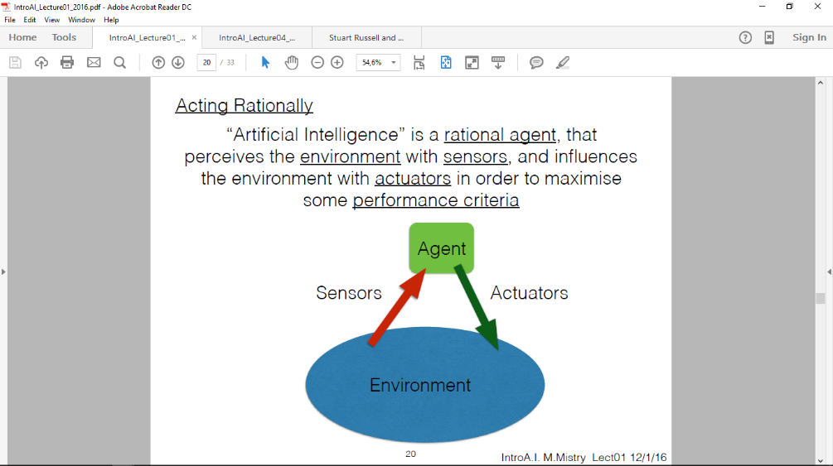Cannot see behind obstacles
      * Sensors are wrong
      * Computation is too slow for a fast changing environment
      * Environment too complex

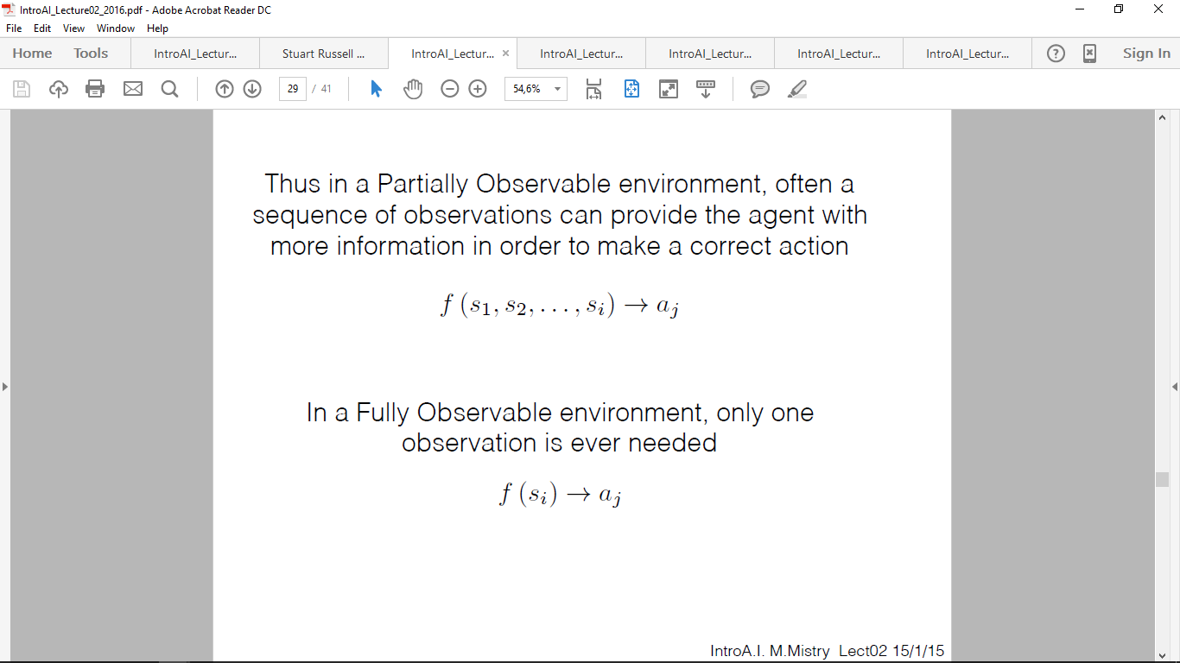

* + - **Fully Observable:** one observation only is needed



* + Ex. Creating a Tic-Tac-Toe playing agent by remembering all of the legal states and memorise (store in memory) which move to make
    - Advantage – no computation therefore fast
    - Disadvantage – cannot change action later
  + **Deterministic Environment:** next state is based on current state
    - Knows the outcome of each action
  + **Stochastic Environment:** cannot determine next state based on current state
    - Uncertain of the outcome of an action
    - if environment is partially observable, treat it as this
    - can make a reasonable guess using probability
  + **Discrete Environment:** finite amount of states
  + **Continuous Environment:** infinite amount of states
* **Multiagents:** each agent has its own performance measure
  + If they are **competing** – PM’s are inversely proportional (chess)
  + If they are **cooperating** – PM’s are directly proportional (same goal)

Searching

* The nodes available for expansion are the **frontiers**
* **Completeness:** Is it guaranteed to find a solution?
* **Optimality:** Is it guaranteed to find the optimal solution?
* **Optimal Solution:** initial 🡪 goal with the least cost
* **Time Complexity:** Time to find the goal in the worst state
* **Space Complexity:** How much memory needed to find the goal in the worst state

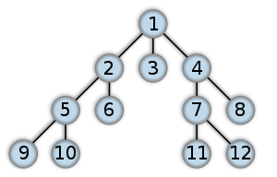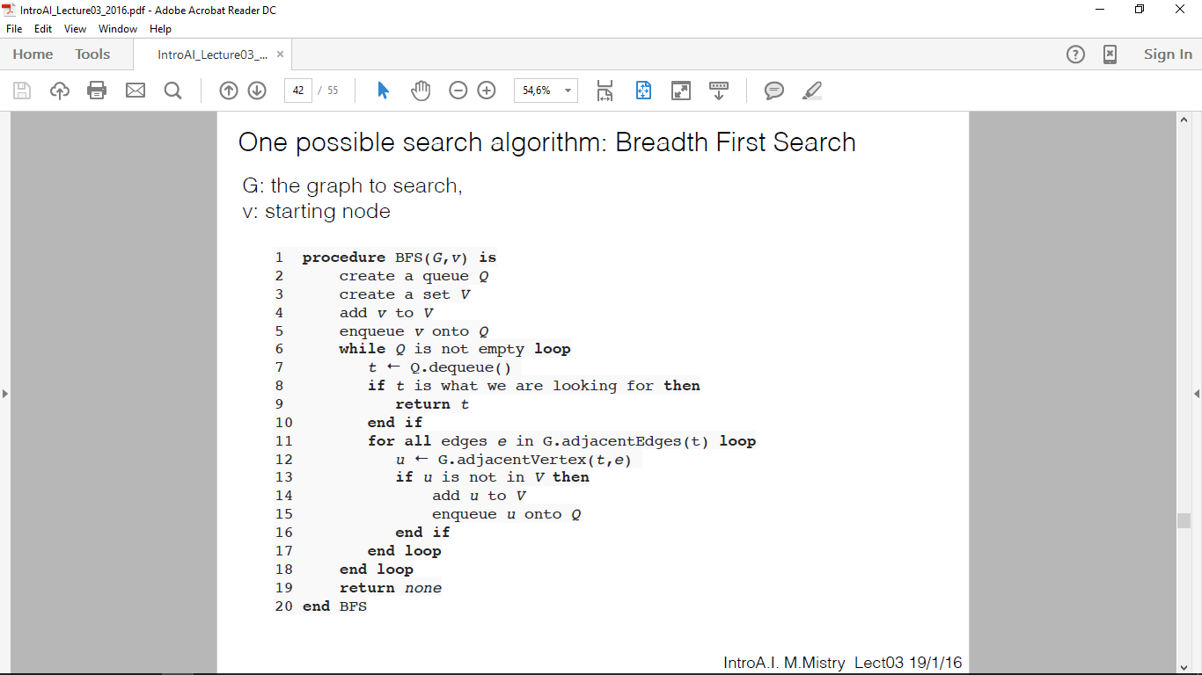**Breadth First Search**

* Always chooses the path with **the least amount of steps**
* After the goal is found we traverse back up the tree to get the path
* **Complete**, every vertex will be expanded
* **Not optimal**, find path with least amount of steps
  + **Optimal** if everything has a uniform cost
* Time complexity is **O(|E|)** – need to traverse every edge in the graph
* Space complexity is **O(|V|)** – have to store every vertex in the graph

**Depth First Search**

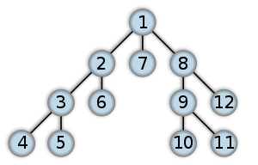

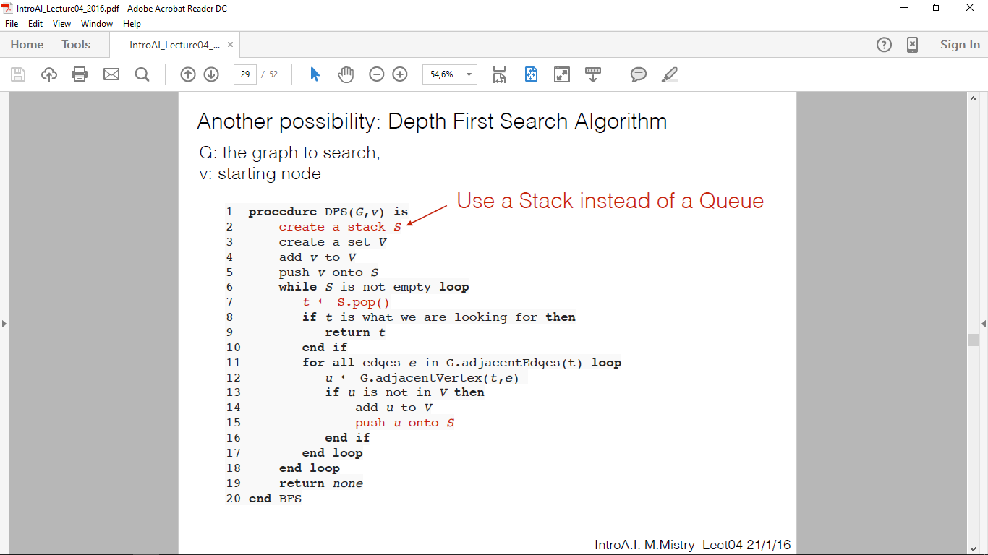

* Find longer paths than BFS
* The way we implemented it, it is **complete**
  + **Not complete in general.** No repeated states or it may get caught in an infinite loop
* **Not optimal**. May return long paths
* **Time Complexity: O(|E|)** without repetition
* **Space Complexity: O(|V|)** without repetititon

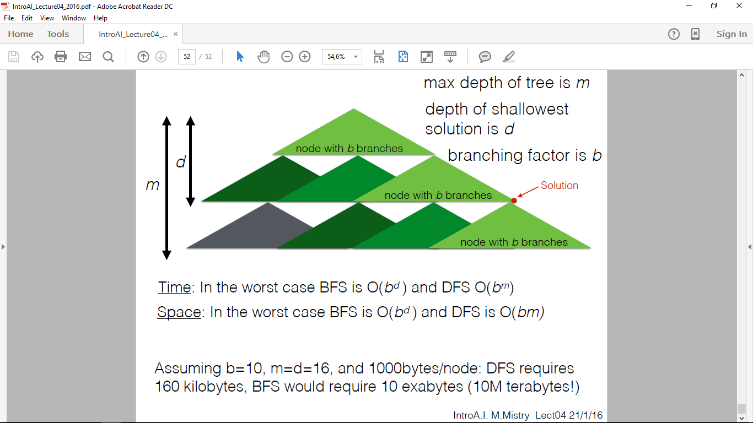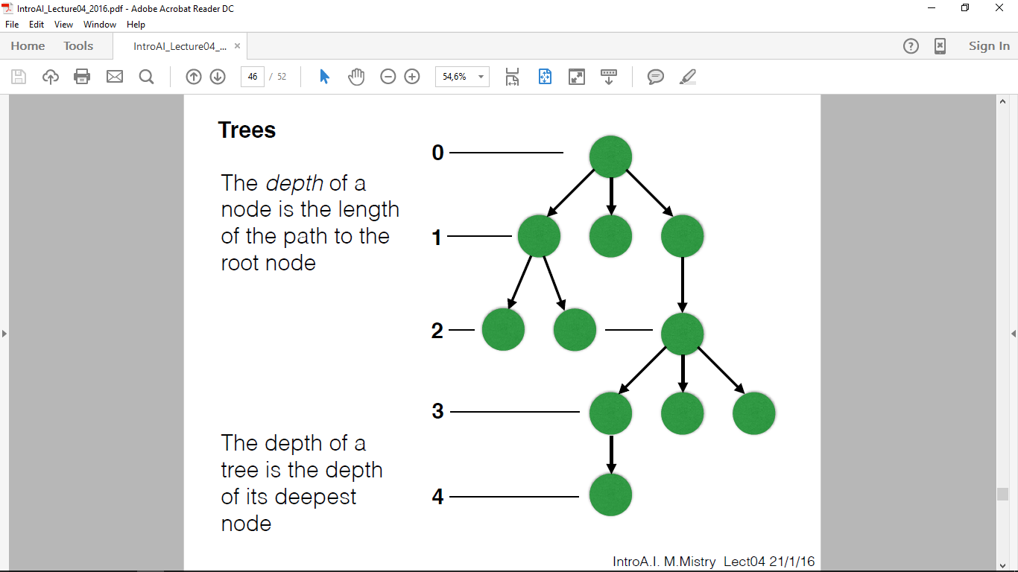

* **Branching factor** is the maximum number of edges on any one node
  + Ex. The previous image has a BF of 3

**Iterative Deeping Search**

Perform DFS but limit the maximum depth to 1. If the goal is not found, clear the entire tree and begin DFS again but maxdepth + 1. Repeat until goal found.

**Uniform Cost Search**

* 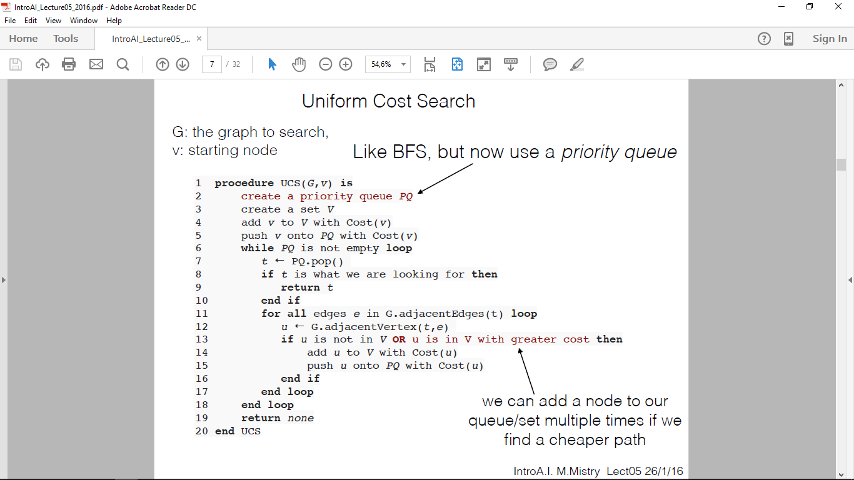expand the node with the **lowest cost** in the priority queue
* **Complete** unless the graph is infinite or there are negative costs
* **Optimal** because we know that when we expand a node, it is with the path of lowest cost
* **Time and Space Complexity: O(b1+C*/e)** where *C\** is the optimal cost and *e* is cost of least cost action assuming e > 0
  + Must wait for goal expansion

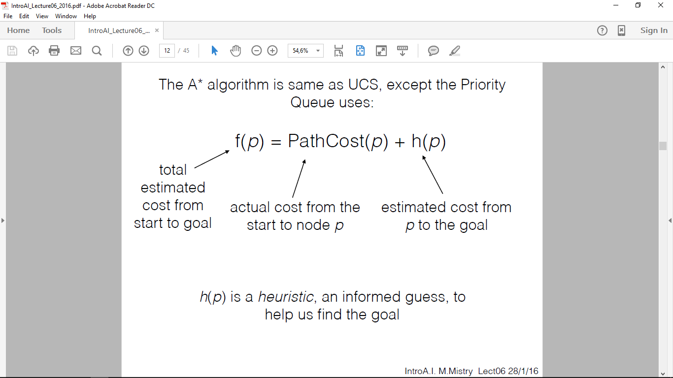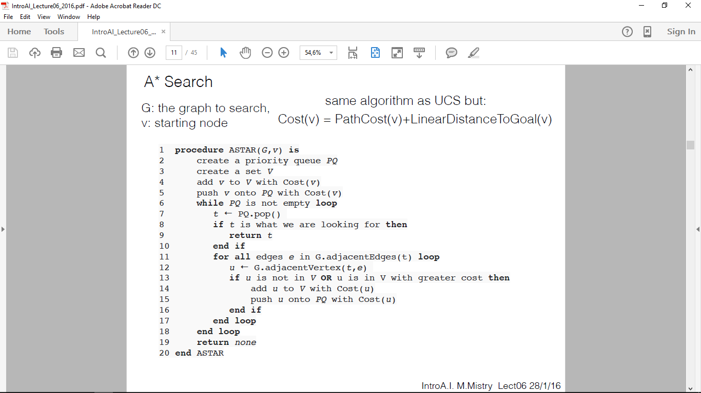**A * Search**

* **Optimal** if the heurisitic is admissable
* **Admissible Heurisitic** is one where it does not **overestimate** the cost of the cheapest path from the initial to the goal
  + If the cheapest path is 10, the heuristic must estimate 10 or less
* **Optimally Efficient**
  + Try to find straightest path possible first
  + Then it will search adjacent nodes of equal cost
  + It will continue to look around it until it reaches the goal with the least possible cost
* **h(p)=0** then you have UCS and the contours would be circles
* **Complete,** finitely many nodes with cost <= C*
* **Time and Space Complexity: O(b1+C*/e)** where *C\** is the optimal cost and *e* is cost of least cost action assuming e > 0
  + in the worst case, h(p) is uninformative

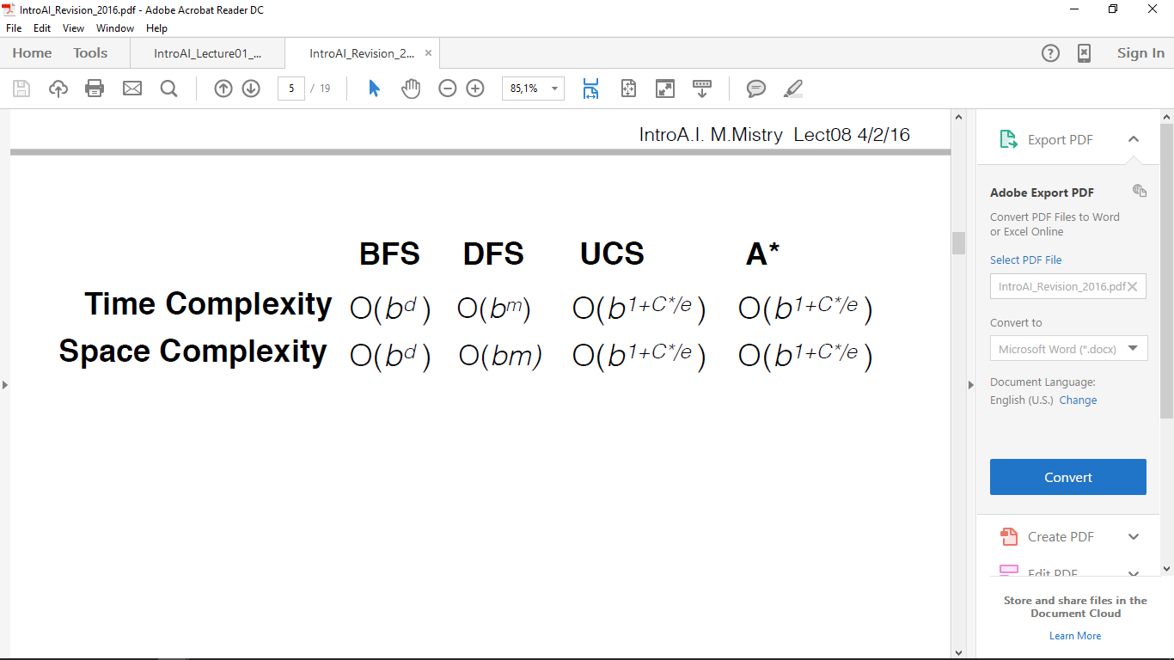

**Minimax Algorithm**

* 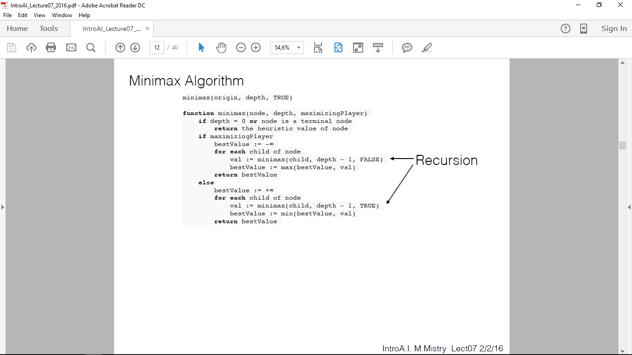**Time Complexity: O(bm)**
* **Space Complexity: O(bm)**

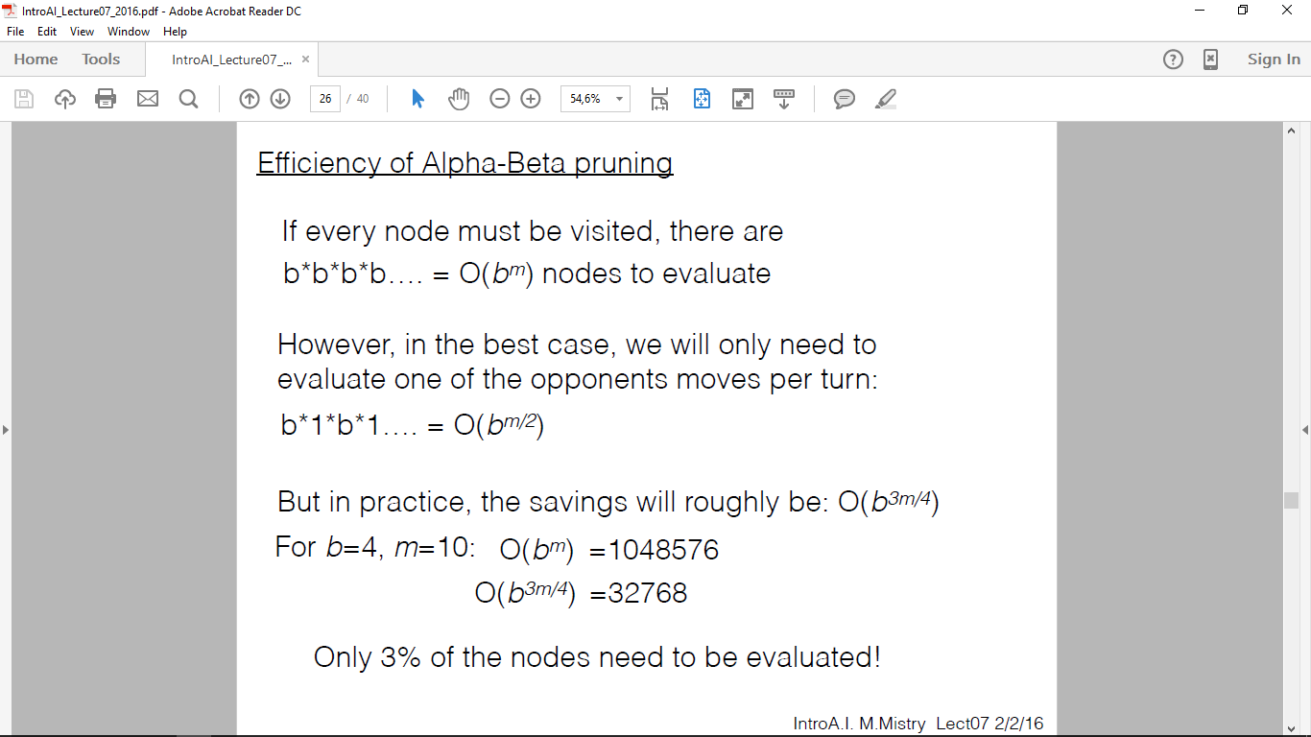**Alpha-Beta Pruning**

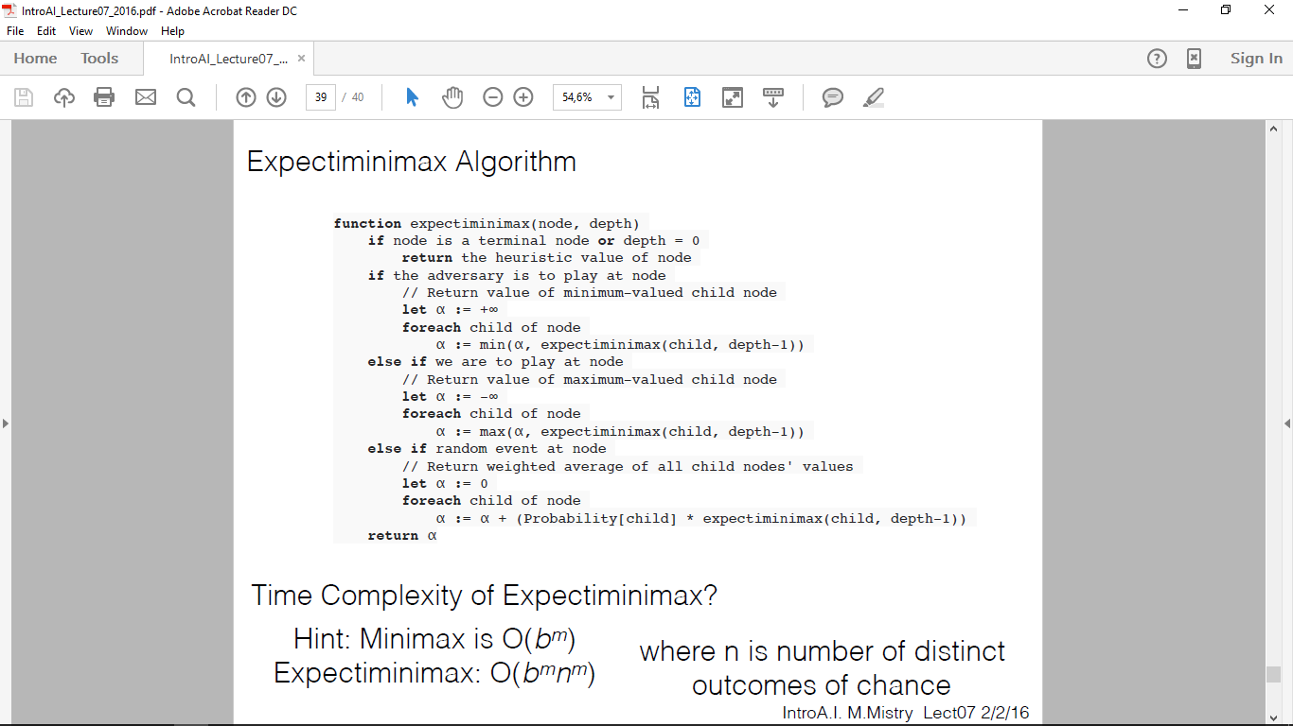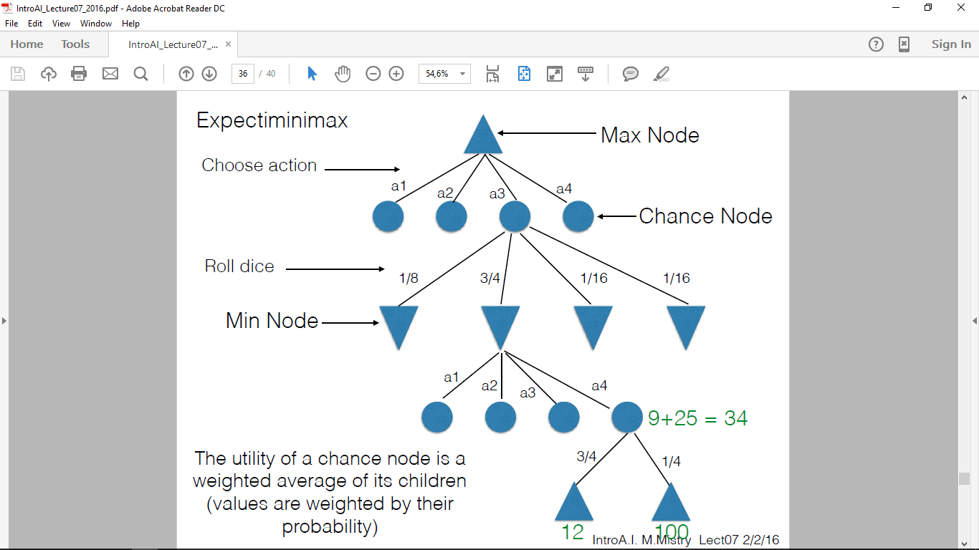**Expectiminimax**

**Monte Carlo Tree Search**

* There are 4 steps
  + Selection
  + Expansion
  + Simulation
  + Back Propgation

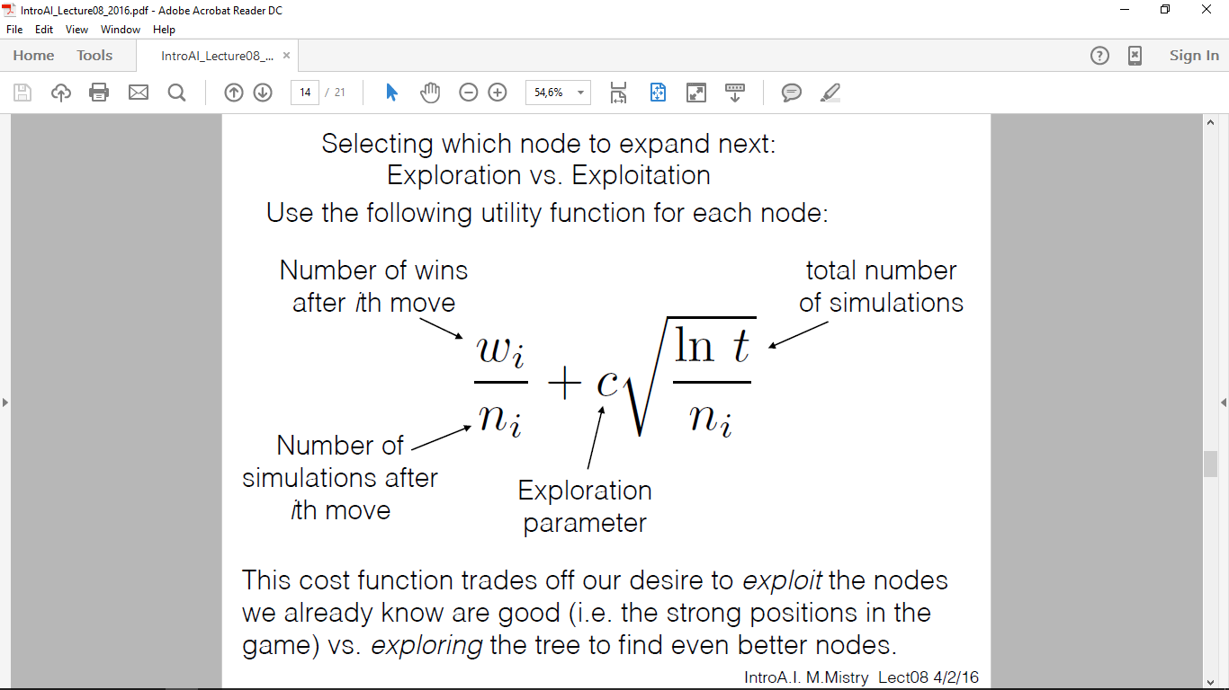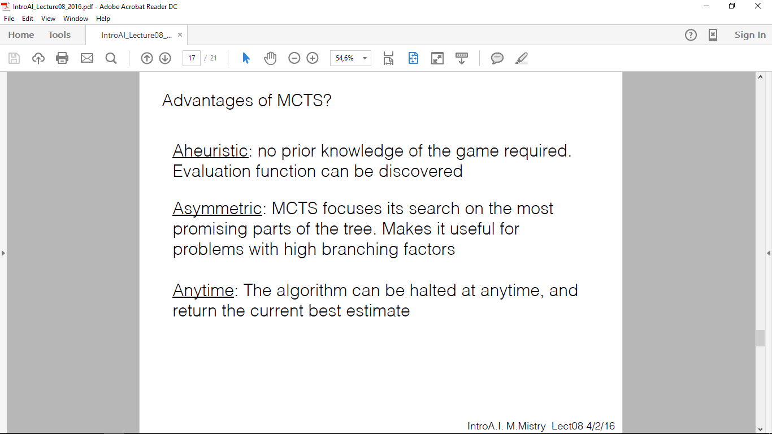

Probability

Lecture 15

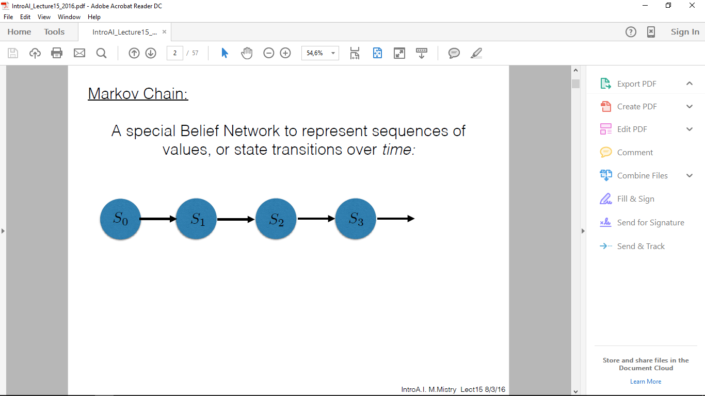**Markov Chain:** sequences of values or state transitions over time

* First Order
  + P(St+1|S0…St) = P(St+1|St)
  + Given the state today, what is the probability of the next state
  + **Future is conditionally independent of the past given the present**
  + History affects future states
* Second Order
  + P(St+1|S0…St) = P(St+1|St, St-1)
* 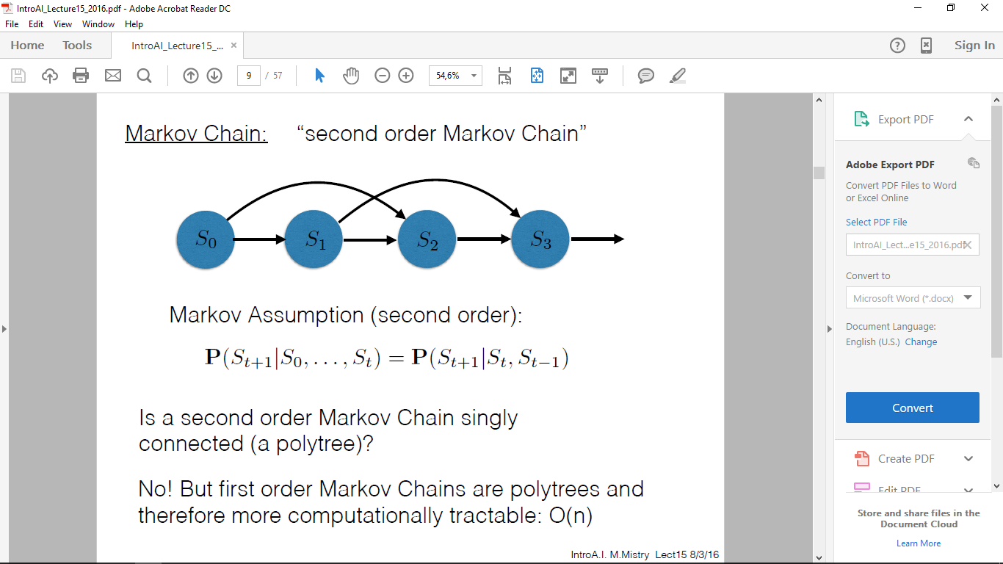MC is **stationary** if transition probabilities do not change over time
  + First Order
    - P(S0) – initial conditions
    - P(St+1|St) – transition probabilities
* 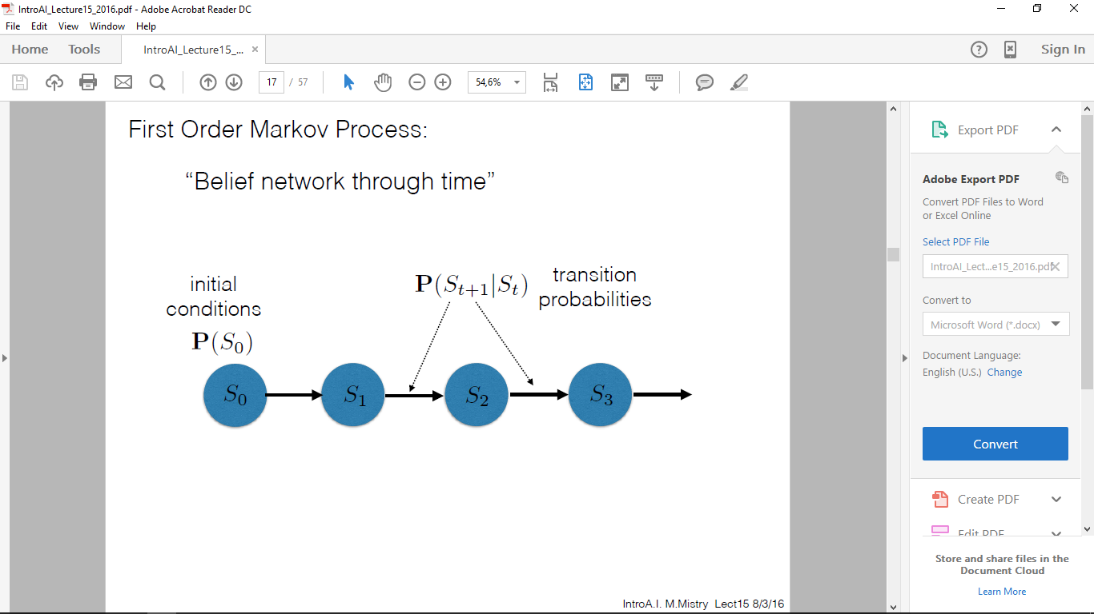**Hidden Markov Model** 
  + Partially observable states
  + Noisy observation
  + 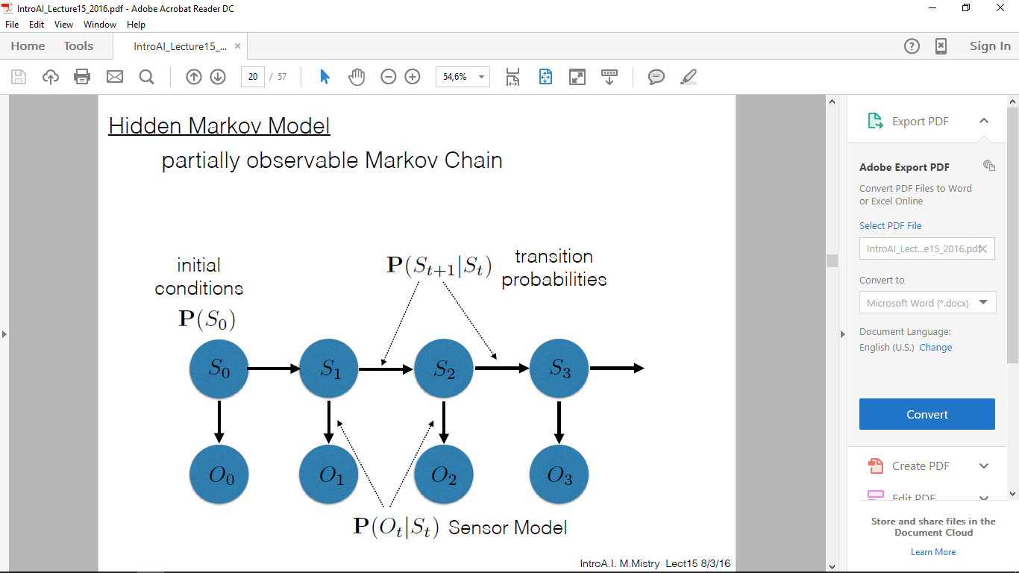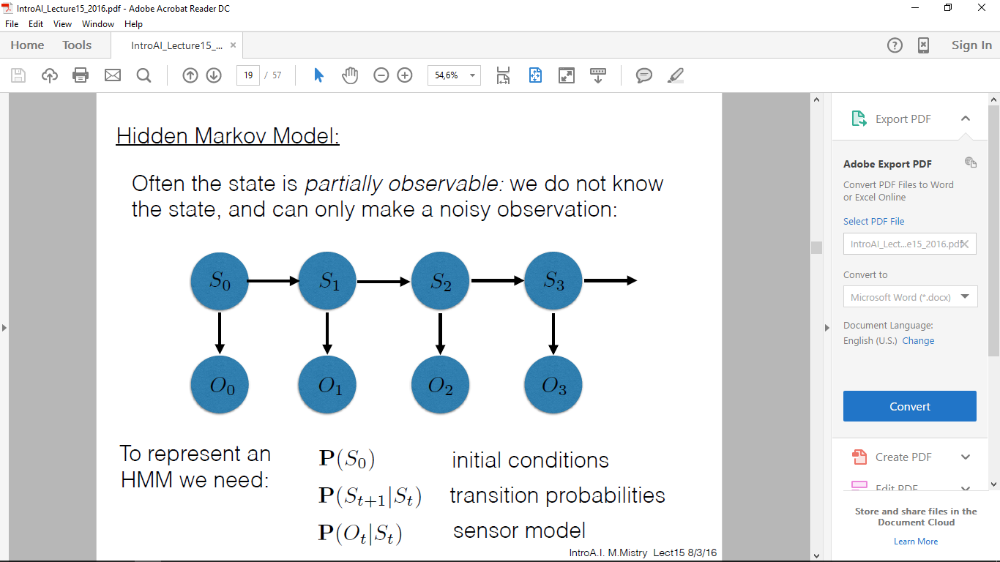determine what state you are in by a **sequence** of past observations
  + **Filtering 🡪** what is the current state given all evidence to date?
  + **Prediction 🡪** what will be the state in the future given all evidence to date?
  + **Smoothing 🡪** what was the state in the past given all evidence to date?
  + **Most likely explanation 🡪** given a sequence of observations, what is most likely sequence of states that can explain the observations?
* 